Chapter 19 Sorting

1 See the text. The time complexity for an insertion sort is O(n^2).

2. omitted

3. n – 1 times

4. See the text. The time complexity for a bubble sort is O(n^2).
5. Omitted.
6. n – 1 times

7. See the text.
8. Omitted.
9. The time complexity for a merge sort is O(nlogn).

10. See the text. The time complexity for a quick sort is O(n^2) in the worst case and O(nlogn) in the average case.
11. Quick sort does not need extra memory for partitioning. The space complexity is O(n).
12. Omitted
13. A binary tree is complete if every level of the tree is full except that the last level may not be full and all the leaves on the last level are placed left-most. A heap is a binary tree with the following properties:

- It is a complete binary tree.
- Each node is greater than or equal to any of its children.
See the text on how to remove the root and how to add an element to the heap.

14. An exception will be thrown if the heap is empty while attempting to remove an element.

15.
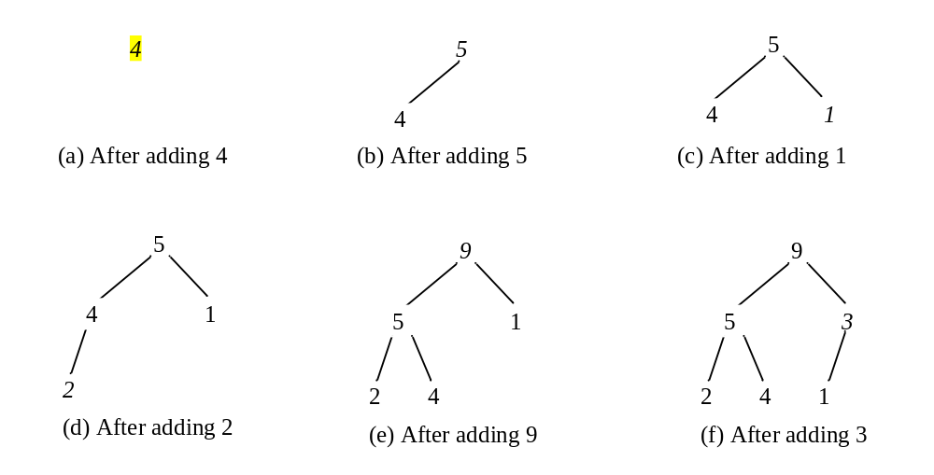
16.
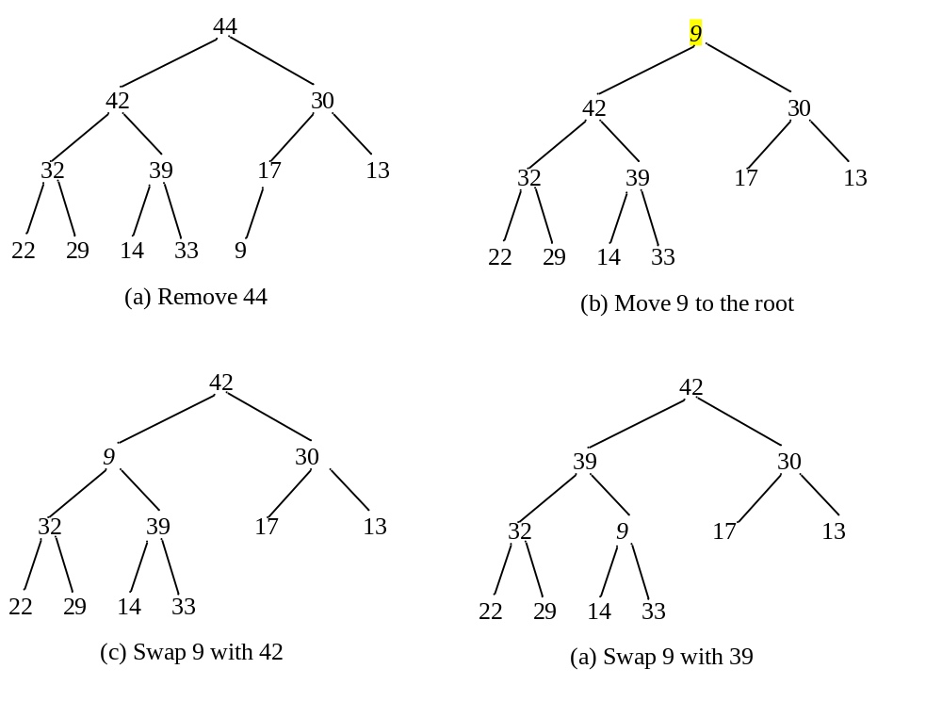
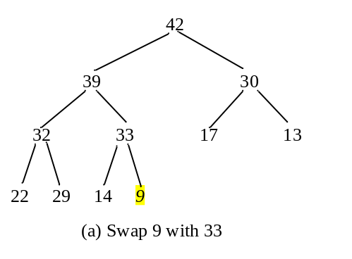
17. O(logn) for both insertion and deletion.

18. Omitted.
19. Omitted.
20. O(nlogn)

21. Bucket sort is not suitable for sorting strings.
22. Omitted.

- See the text. The time complexity for an external sort is O(nlogn) on disk I/O of blocks of data.
- Omitted.

